**INDIAN INSTITUTE OF REMOTE SENSING**

Module name: Programming for Geodata processing

BY

**Rachit M. Patel**

(STUDENT ID:202219028)

**MASTER OF SCIENCE IN**

**AGRICULTURE ANALYTICS**

SUBMITTED TO:

**DR. PRASUN KUMAR GUPTA**



**Indian Institute of Remote Sensing.**

**ISRO, DEPT OF SPACE, GOV.OF INDIA,**

**DEHRADUN-248001, UTTARAKHAND, INDIA**

**ABSTARCT**

* The **Expanding universe** is one of the amazing scientific discoveries in the human History. It was all started in 1924 when **Edwin Hubble** discovered that there are other galaxies in our **Universe,** we are the not only galaxy in this Universe.
* In order to prove the distances of other galaxies he used the indirect methods to measure distances of other Galaxies. He measured the distances of stars present in other galaxies so that he could get distance of that Galaxy. The relative brightness of star depends on the how much light (luminosity) star radiates and how far that is away from our milky way. we can measure the brightness of nearby stars and their distances so we can find the luminosity of those stars. As we know the luminosity of nearby stars we can compare their luminosity to luminosity of other stars that are present in other galaxies and we can get their distances.
* If we look at the spectrum of the sun then we will see the dark lines because certain elements present in sun absorbs the certain wavelengths. As we see the spectrum of distant galaxies, we will see the dark lines in the spectrum but they all are shifted to red end of spectrum which is the peculiar thing that astronomers and Edwin Hubble observed.
* In 1920s when Astronomers looked at the spectra of different stars from other Galaxies, they found out that something strange is going on the spectra of different stars in different distant galaxies they all were shifted to the red end of spectrum that redshift values t(z) of other galaxies shows that they all are moving away from each other! which leads astronomers to look at the universe in different Perspective.

**The Introduction And Dataset**

* **Claim:**

According to **Nasa’s cosmic times** The Universe is Expanding and it is not static which was proved by Edwin Hubble in 1929. His research shows that the Galaxies are Moving away from each other and he measured it via Redshift values of those galaxies.

* **Datasets:**
* There are 3 Datasets from 3 different websites.
* The first data set contains the list of distant astronomical objects along with their light travel distance, their type and cosmological redshifts of their spectra. This data contains spectroscopic redshift values because photometric redshifts are very faint often give the false values of redshift phenomenon.

1.<https://en.wikipedia.org/wiki/List_of_the_most_distant_astronomical_objects>

* The second data set contains the list of different nearby stars along with their name and redshift values. The third dataset also contains distant astronomical objects like different constellations and their redshift(z) values.

2.<https://www.researchgate.net/publication/349361419_Unexpected_Redshift_of_nearby_stars>

3.<http://spiff.rit.edu/classes/phys200/lectures/redshift/redshift.html>

* Among All the datasets the common the distance and redshift both are the most common features which is used to analyse the datasets and relationship between them is important to prove the claim.
* These datasets contain some none values and black values which leads to some errors although other than none value data other data are accurate which is measured by deep space telescopes and interstellar missions. Dataset cleaning is needed because the presence of none values as well as the approximate data and some unordered, uncertain special Characters.

**Research Question:**

* **News Article:**

According to **Nasa’s cosmic times** **The Universe is Expanding** and it is not static which is proved by Edwin Hubble in 1929. His research shows that the Galaxies are Moving away from each other and he measured it via Redshift values of those galaxies.

**Link:**

[**https://imagine.gsfc.nasa.gov/educators/programs/cosmictimes/educators/guide/1929/expanding.html**](https://imagine.gsfc.nasa.gov/educators/programs/cosmictimes/educators/guide/1929/expanding.html)

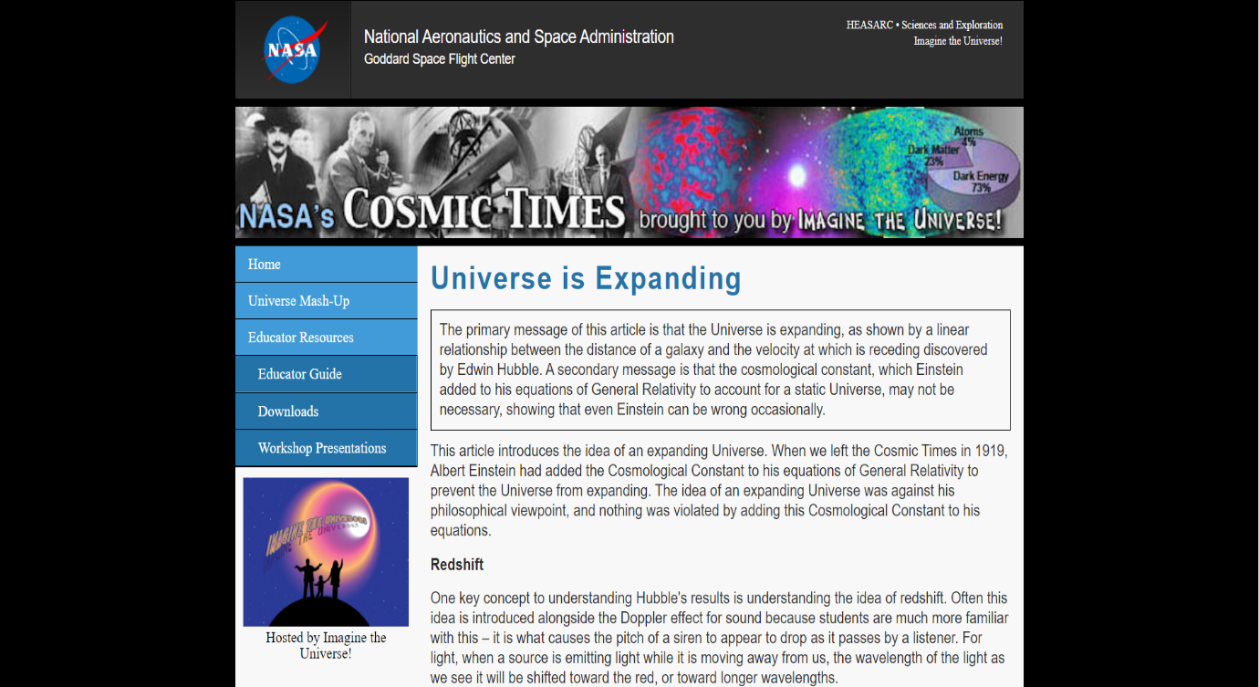

* **Claim:**
* The Universe is Expanding. Galaxies and distant Astronomical objects are moving away from each other. Further Astronomical objects are moving away from us faster than those Astronomical objects which are nearer to us.

**Research Question:**

**How The universe is expanding?**

* Hubble and his observations about the galaxies are the key element which supports this claim and **Doppler effect** which is best way to understand and prove the expansion of our universe by measuring the different frequencies of spectra of different stars and galaxies.
* Hubble stated that the galaxies which is nearer to us are shifted to slightly blue end of spectrum but those galaxies which is far away from us their spectra are shifted to red end of spectrum.
* Doppler Effect as Source Moving Towards the Observer, the Observer will get the higher Frequency and if the source moving away from the Observer the Observer will get the lesser Frequency.
* When the source moving towards us it’s spectra of black lines will shifted to blue end of spectrum because each time it emits the waves it would take lesser time for those frequencies to reach at us than previous one so as source moving towards us we will get high frequency time by time their frequency will shifted to blue end of spectrum.
* The spectrum of the sun consists the dark lines because certain elements present in sun absorbs the certain wavelengths. As we see the spectrum of distant galaxies, we will see the same dark lines in the spectrum but they all are shifted to red end of spectrum which is the peculiar thing that astronomers and Edwin Hubble observed, they called it **Redshift of light.**
* If the source moving away from us then it would take more and more time for waves to reach at us than previous waves so their spectra of dark lines will shifted to red end of spectrum it suggests that those galaxies are moving away from us. This phenomenon called as **Doppler Redshift.**
* In order to support this claim, we need the Redshift values of nearby Galaxies and stars as well as the distant galaxies and stars by comparing them we can prove our claim.
* The further the galaxy resides from us we will give the high red shift value of that galaxy which states that the further the galaxy is the more chances that it is moving away from us which supports the research question.

**Analysis**

* As we focus the Telescopes to the interstellar space, we will get the different spectra of light from Different stars in different Galaxies.
* In 1929 Astronomers observed the different spectrums of different stars in different galaxies what they had found was very strange they have found out that the spectra of those different stars from all those distant different galaxies is shifted to **red end of spectrum.**
* **The Doppler Effect** is best way to prove those redshifts. we all know that Frequency which is number of waves per one second. Our eyes identifies the lower frequencies at red end of spectrum and higher frequencies at the blue end of spectrum.
* In order to support the claim, we need the Redshift values of different astronomical objects so that we can observe their redshift values, distances then we can compare them.
* As we observe the spectrums of stars which coming nearer to us, we will find that as the star moving towards to us then time takes to reach the wave crests to us which will lesser and lesser because star is moving towards us.
* Same physics applies for the stars and galaxies which are moving away from us. we will find that as star moving away from us then it would take more and more time for wave crests to reach at us and their spectra will shifted to red-end of spectrum, as per the doppler effect it proves that those stars and galaxies are moving away from us.
* stars moving away from us their respective spectrums will shifted to red end of spectrum which shows that wave crest of that spectrum galaxy needs to travel more distance due that doppler effect their spectrum shifted to Red end of spectrum.
* As star moving towards us their respective spectrum will shifted to blue end of spectrum which shows that galaxies which are nearer to us their wave crests of spectrum need to travel lesser distance as compared to those galaxies which are far away from us.
* The stars which present in our milky way also moving away from us but not as fast as those stars which are far away from us.

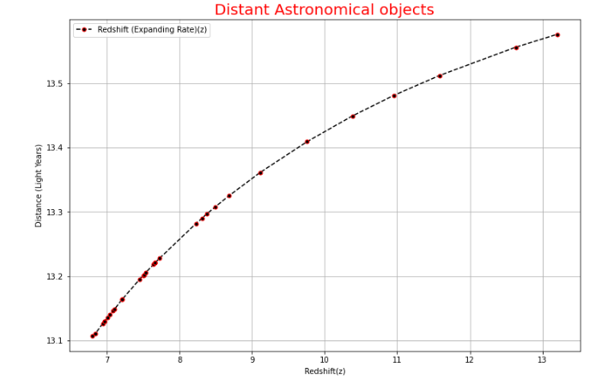

* In this graph we can see that those astronomical objects which has lesser distance their redshift values are much lesser as compared to the galaxies which resides in higher distance.
* As we can see that the redshift values are increasing as the distance increasing which states that the galaxies which are far away from us their red shift values are increasing
* Those Galaxies which are nearer to us their redshift values are lesser because their spectrums are shifted to blue end of spectrum.
* The increasing rate of redshift values states that galaxies which are stays away from us are moving away from us because the wave crests of their spectrum of light needs to travel more distance as compared those galaxies which are nearer to us.
* Those stars which are nearer to us are also moving away from us but lesser as compared to those stars and galaxies which are far away from us.

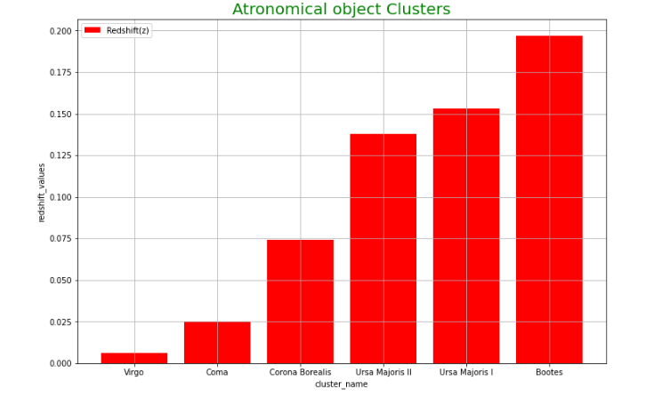

* This Graph contains different constellations and astronomical objects we can see that the constellations, which are far away from us their redshift values are very high and those constellations which are nearer to us their red-shift values are lesser.

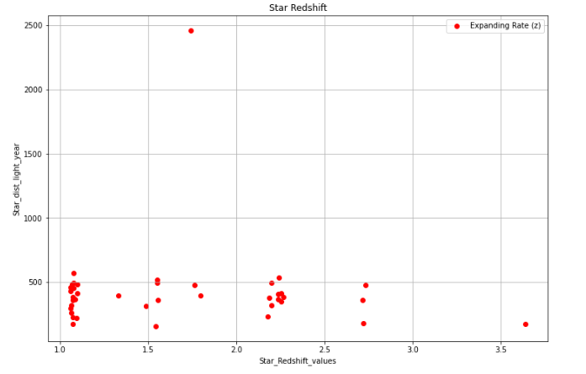

* In This graph we can see that all those stars which are nearer to us their spectrum is shifted to red-end of spectrum. This suggests that the nearer stars are also moving away from each other.
* These graphs suggest that the stars which are further away from us it is moving away from us but those stars which are nearer to us are showing the astronomical redshift it shows that nearer galaxies, stars are also moving away from us.

**Conclusion:**

* As per the above data and its analysis, we can state that the Astronomical objects which are further away from Earth, their rate of Redshift values are increases.it suggests that those objects are moving away from us. Astronomical objects nearer to Earth their spectrum is also shift to the red-end of spectrum. It shows us that these stars and galaxies those are nearer to us are also moving away from us. It concludes that the universe is expanding in every direction we see. Those Aforementioned graphs are showing the same results as we predicted earlier and it supports our claim about expanding Universe.
* In order to see the expanding universe, we have to zoom out further and further as we can see whole universe as cosmic fluid (galaxy clusters, stars, all are in one cup of glass). cosmologists say it as homogeneous universe, every direction we see universe will look identical and this is the identical condition where we can see the expansion of universe as the time passing, we will see that the density of cosmic fluid is decreasing so expanding universe is phenomenon which is larger scale phenomenon as compared to in between universe objects.
* The Results of the above data shows that in every direction we see we will find the objects in that direction which will shifted to red end of spectrum it shows that every object is moving away from each other it supports our claim that Universe is Expanding.

**References:**

**[offline Article]**

**The Brief History of Time (From the Big Bang to Black Holes)**

**By Stephan hawking**

[**https://en.wikipedia.org/wiki/A_Brief_History_of_Time**](https://en.wikipedia.org/wiki/A_Brief_History_of_Time)

**[Online Articles]**

NASA’s Cosmic Times

[**https://imagine.gsfc.nasa.gov/educators/programs/cosmictimes/educators/guide/1929/expanding.html**](https://imagine.gsfc.nasa.gov/educators/programs/cosmictimes/educators/guide/1929/expanding.html)

**IOWA (Physics and Astronomy)**

[**https://itu.physics.uiowa.edu/labs/advanced/astronomical-redshift**](https://itu.physics.uiowa.edu/labs/advanced/astronomical-redshift)

**Redshift and evidence for an Expanding Universe**

[**http://spiff.rit.edu/classes/phys200/lectures/redshift/redshift.html**](http://spiff.rit.edu/classes/phys200/lectures/redshift/redshift.html)